**FYP Proposal Document Template**

**Automated Modulation Classification**

Final Year Project Proposal by

**Names**

**Fahad Zaheer (287576)**

**Haider Mustafa (283213)**

**Advisor: Dr. Safdar Abbas Khan Co-Advisor: Dr. Khuram Shahzad**

School of Electrical Engineering and Computer Science National University of Sciences and Technology

Islamabad, Pakistan (2022)

1

# ABSTRACT

Automated Modulation Classification (AMC) aims to identify the type of modulation received as an incoming signal at the receiver which then demodulates and retrieves the original information. AMC processes signals in the physical layer of wireless communication system to increase the effectiveness of spectrum utilization. AMC is used in electronic warfare, and civil monitoring scenarios. In our project, we plan to implement a modulation classifier based on Deep Learning approach. Since we have sufficient data, we expect that Deep Learning will be more reliable as well as accurate in classifying modulations on a lower SNR. But Automated Modulation Classification confronts challenges such as intra-class discrimination of higher order modulation such as FSK, m- QAM.

**INTRODUCTION**

A digital communication system converts the messages produced by the source, which are typically in analogue form, into digital format before transmitting them. In order to approximate the original message, the received digital data is converted back to analogue at the receiver end. [4]

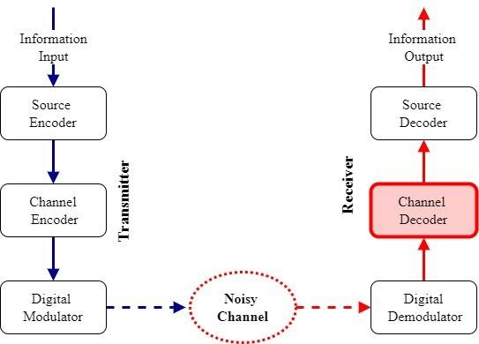

Over the years standards and technologies used in wireless communications have advanced rapidly, thus autonomous understanding of radio spectrum plays a crucial role in different applications. Co-channel interference and signal distortion over propagation channels are two unfavorable effects of densely connected networks that aggressively use spectrum to handle extremely high traffic in large-scale wireless communication systems. Additionally, radio signals can be encoded using a variety of modulation formats from a pre-defined candidate pool using the non-cooperative configuration used in contemporary communication systems to achieve intelligent spectrum management. The modulation format is chosen based on the system requirements and channel conditions.

Automatic modulation classification is a technique for classifying different types of signal modulation automatically aiding the receiver in demodulation of the signal. It is frequently utilized in domains like interference detection, spectrum sensing, electronic defenses, electronic warfare, threat analysis in military scenarios, spectrum interference detection, dynamic spectrum access, and monitoring civil scenarios, and thus there is a dire need of developing an effective algorithm for modulation classification in different software-defined radio-based communications. With the substantial advancement of radio communication, the electromagnetic environment and signal modulation are becoming more complicated and varied, resulting in a high noise level, typically greater than 100 dBHz, and an exceedingly low SNR [1]. The dynamic range of the intercepted signal's SNR is constantly shifting because of the low probability of the intercept (LPI), which also causes the range of SNR to expand significantly. Furthermore, there are Higher Order of Modulations for each family of Modulation that makes AMC tasks more challenging due to these new circumstances. Therefore, it is essential to research more practical AMC methods.

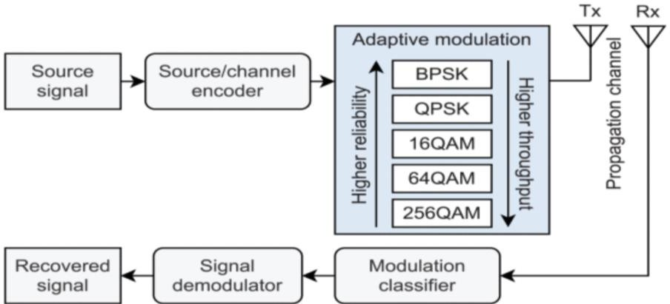

In more concrete terms, conventional feature engineering techniques (such as feature extraction and feature selection) can be used to gather the underlying radio characteristics, including the knowledge of modulation type, in order to learn a classification model through supervised or unsupervised learning. [3]

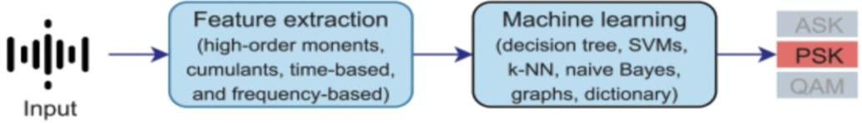

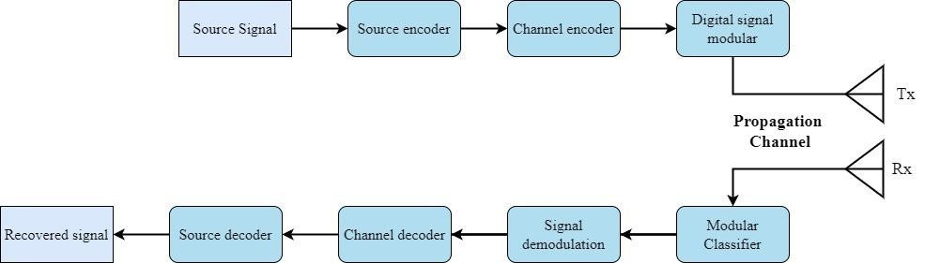To strike a good balance between spectrum efficiency and transmission reliability, numerous cutting-edge analogue and digital modulation techniques have been used in communication systems over the past few decades. A transmission signal is encoded in analogue communication systems using analogue modulations like amplitude modulation (AM), phase modulation (PM), and frequency modulation (FM). A high-frequency periodic waveform is typically used in analogue modulation techniques to encrypt an analogue baseband signal, also known as the source signal (so-called the carrier signal). Due to better coordination with digital data and greater robustness against interference, digital modulations are more advantageous in terms of usage than analogue modulations. The source signal is first converted to a digital signal by means of sampling and quantization. The resulting digital signal is then encoded to increase data security and minimize the transmission errors before being passed to a digital modulator. Digital modulations such as frequency-shift keying (FSK), amplitude-shift keying (ASK), phase-shift keying (PSK), pulse amplitude modulation (PAM), amplitude and phase- shift keying (APSK), and quadrature amplitude modulation (QAM) are frequently used. Different waveform properties of the carrier signal, such as amplitude, frequency, phase, and a combination of amplitude and phase, can be changed during the modulation process depending on the predefined modulation technique. An incoming signal's radio characteristics are inferred using a learned AI model to determine the most suitable modulation over propagation channels.

**PROBLEM STATEMENT**

## Unmet need or Problem

The most common question is why do we need Automated Modulation Classification? The question is intriguing yet the answer to is not that complicated. Modulation needs to be classified before they can be demodulated by the receiver. This is mainly used by agencies, and military for defense scenarios as well as electronic warfare.

Though we have seen incredible advances in Deep Learning Algorithms and Tools, but at the same time the number of modulations format has also increased, moreover there is another challenge of intra-class discrimination of higher order modulation.

## Who needs it

The main stakeholders are:

1. Armed Forces
2. Security Agencies
3. Government Companies

Thus, this project can help the listed stakeholders to achieve their goals in an efficient way.

# LITERATURE REVIEW

Many Automated Modulation Classification techniques have been put forth to help with intelligent spectrum management and dynamic spectrum access. This section provides a brief overview of the current traditional AMC techniques, the majority of which can be divided into likelihood-based (LB) and feature-based (FB) approaches. [2]

## Signal Model

Firstly, let us look at the regular signal model which is used in single-input, single-output, single-carrier systems under the presence of deteriorated channel

where An is the signal amplitude of symbol n, fo is the carrier frequency offset, θn is the varying phase offset, T is the symbol spacing (or interval), h(⋅) denotes the synthetic effect of the residual baseband channel, x[k] denotes the symbol sequence of the original data

over a specific modulation scheme, and ϵT is the timing offset between the transmitter and the receiver. Subsequently, the complex envelope of the received radio signal y[n] is expressed as follows:

where w[n] is the additive white Gaussian noise (AWGN). In communication systems, an AMC approach aims to predict the modulation format of x[n, Hk] precisely without the channel state information Hk by learning the underlying features of the received signal y[n]

.

## Traditional Approaches

Many AMC methods in this group have deployed probabilistic frameworks in likelihood- based approaches and traditional machine learning frameworks in feature-based approaches. Generally, the likelihood-based approaches apply probability theories and hypothesis models to solve modulation identification problems under the conditions of known and unknown channel information [5]. Although the likelihood-based approaches can reach the optimal classification accuracy with the perfect knowledge of signal model and channel model (which cannot be obtained in the real world), they require high computation complexity to estimate model parameters [6], [7]. By following a regular machine learning (ML) framework for classification task, the feature-based approaches are more favorable to deploy in practical systems compared to the likelihood-based approaches, thanks to their relatively easy implementation and low complexity [8]. Despite being flexible with different channel models, the feature-based approaches face some major drawbacks: weakly discriminative experience of handcrafted features and limited learning capacity of traditional classification algorithms [9] – [11].

# PROJECT OVERIEW/GOAL

The main goal of the project is to assist the wireless communication process. Signals are firstly encoded, then modulated before transmitting them through the propagation channel, when we intercept those audios, they ought to be demodulated and decoded before they are useful. For demodulation we need to identify their modulation type. This is where Modulation Classification comes into picture. Once the modulation is identified, it can be demodulated by using a demodulator device. Automatic Modulation Classification can automate this process. By automatically

classifying the modulations we can create a pipeline which will make the intercepted sound signals audible.

# PROJECT DEVELOPMENT METHODLOGY / ARCHITECTURE

Initially, we will carry out pre-processing, where we will perform denoising on the data using Savitzky-Golay filter and Hilbert Huang transform. NESCOM has provided us with the dataset, which is labeled. We will be using supervised learning and ensemble architecture in which the predictions from first layer of models will be fed into a meta classifier which will take that predictions as the feature and predict using them as input. This will help in classifying the higher order modulations, which will be a challenge.

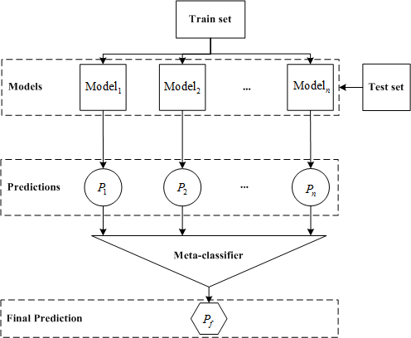

[12]

# PROJECT MILESTONES AND DELIVERABLES

There will be 3 major milestones in this project

1. Design and develop an ensemble learning based Automated Modulation Classification model using Neural Networks.
2. Finding an optimal configuration of Neural Network which will work for low SNR and accuracy of above 90% for 10 modulation schemes.
3. Evaluating AMC on both simulated and real-world data.
4. Development of offline AMC application as a general deep learning framework for any classification problem related to RF signals.

The Gantt Chart is given below:



# WORK DIVISION

## Haider Mustafa

* + Data Preprocessing – Cleans the noise from the data and applies transformations for smoothing of data.
  + Data visualization and separating the train and test data.

## Fahad Zaheer

* + Trying and analyzing results of different models such as Convolutional Neural Network, Long short-term memory, and Sparse Auto Encoder etc.
  + Analyzing stacking ensemble learning and parallel approach.

# COSTING

Cost incurred to collect the dataset as well as deploy the model, and any other type of cost will be funded by NESCOM.

# REFERENCES

1. Han H, Ren Z, Li L, Zhu Z. Automatic Modulation Classification Based on Deep Feature Fusion for High Noise Level and Large Dynamic Input. Sensors (Basel). 2021 Mar 17;21(6):2117. doi: 10.3390/s21062117. PMID: 33803042; PMCID: PMC8003108.
2. Zhou, S., Yin, Z., Wu, Z. et al. A robust modulation classification method using convolutional neural networks. EURASIP J. Adv. Signal Process. 2019, 21 (2019). <https://doi.org/10.1186/s13634-019-0616-6>
3. T. Huynh-The et al., "Automatic Modulation Classification: A Deep Architecture Survey," in IEEE Access, vol. 9, pp. 142950-142971, 2021, doi: 10.1109/ACCESS.2021.3120419.
4. Carl Nassar, Chapter 1 - Introducing Telecommunications, Editor(s): Carl Nassar, Telecommunications Demystified, Newnes, 2001, Pages 1-11, ISBN 9780080518671, <https://doi.org/10.1016/B978-0-08-051867-1.50007-X>. (<https://www.sciencedirect.com/science/article/pii/B978008051867150007X>)
5. W. Su, J. L. Xu and M. Zhou, "Real-time modulation classification based on maximum likelihood", IEEE Commun. Lett., vol. 12, no. 11, pp. 801-803, Dec. 2008.
6. J. L. Xu, W. Su and M. Zhou, "Likelihood-ratio approaches to automatic modulation classification", IEEE Trans. Syst. Man Cybern. C Appl. Rev., vol. 41, no. 4, pp. 455-469, Jul. 2011.
7. O. Ozdemir, R. Li and P. K. Varshney, "Hybrid maximum likelihood modulation classification using multiple radios", IEEE Commun. Lett., vol. 17, no. 10, pp. 1889-1892, Oct. 2013.
8. S. Majhi, R. Gupta, W. Xiang and S. Glisic, "Hierarchical hypothesis and feature-based blind modulation classification for linearly modulated signals", IEEE Trans. Veh. Technol., vol. 66, no. 12, pp. 11057-11069, Dec. 2017.
9. V. D. Orlic and M. L. Dukic, "Automatic modulation classification algorithm using higher- order cumulants under real-world channel conditions", IEEE Commun. Lett., vol. 13, no. 12, pp. 917-919, Dec. 2009.
10. B. Ramkumar, "Automatic modulation classification for cognitive radios using cyclic feature detection", IEEE Circuits Syst. Mag., vol. 9, no. 2, pp. 27-45, Jun. 2009.
11. W. Su, "Feature space analysis of modulation classification using very high-order statistics", IEEE Commun. Lett., vol. 17, no. 9, pp. 1688-1691, Sep. 2013.
12. SSEM: A Novel Self-Adaptive Stacking Ensemble Model for Classification - Scientific Figure on ResearchGate. Available from: https://[www.researchgate.net/figure/The-architecture-](http://www.researchgate.net/figure/The-architecture-) of-the-stacking-ensemble-learning-In-the-base-classifiers-the-training_fig1_335156833